Grade 7 Accelerated · Unit 6 · Practice Test  Relationships in Triangles  18 points ANSWER KEY | Name  Date  Period

Show your work. One point for each lettered part.
Part 1. Triangle Inequality and the Converse 3 points MA.8.GR.1.3
1. Which set of side lengths can form a triangle? 1 pt
○ A. 4 cm, 7 cm, 11 cm
○ B. 12 cm, 5 cm, 6 cm
● C. 6 cm, 8 cm, 13 cm
○ D. 3 cm, 10 cm, 15 cm
C
The two shorter sides against the longest: 6 + 8 = 14, more than 13. A lies flat; B and D pass only when the wrong pair is added.
Scoring: 1 point.

2. Select ALL of the sets of side lengths that make a right triangle. 1 pt
☒ A. 17, 8, 15
☐ B. 5, 6, 7
☒ C. 20, 21, 29
☐ D. 7, 24, 26
☐ E. 4, 6, 8
A and C
Square all three and test the longest as c: 64 + 225 = 289 = 17² (the longest listed first) and 400 + 441 = 841 = 29². Both and nothing else for the point.
Scoring: 1 point.

3. Two sides of a triangle are 6 inches and 15 inches long. Which inequality shows every possible length x, in inches, of the third side? 1 pt
○ A. 
● B. 
○ C. 
○ D. 
B
15 − 6 = 9 and 15 + 6 = 21, never equal to either.
Scoring: 1 point.

Part 2. The Pythagorean Theorem 6 points MA.8.GR.1.1
If an earlier part is wrong, a later part still earns its point when the right operation is applied to your own earlier answer — but only if that work is on the page.
4. Find the missing side of each right triangle.
a. Its legs are 9 inches and 12 inches. How long is the hypotenuse? 1 pt
15 in
c² = 81 + 144 = 225
b. Its hypotenuse is 61 meters and one leg is 60 meters. How long is the other leg? 1 pt
11 m
a leg: subtract — 3,721 − 3,600 = 121. Adding the squares gives a 'leg' longer than the hypotenuse.
Scoring: a 1 · b 1 = 2 points.

5. A right triangle has legs of 7 centimeters and 13 centimeters. How long is the hypotenuse, in centimeters? Round your answer to the nearest tenth. 1 pt
14.8 cm (exactly √218 cm)
c² = 49 + 169 = 218; √218 = 14.76…
Scoring: 1 point.

6. Which equation can be used to find x? 1 pt
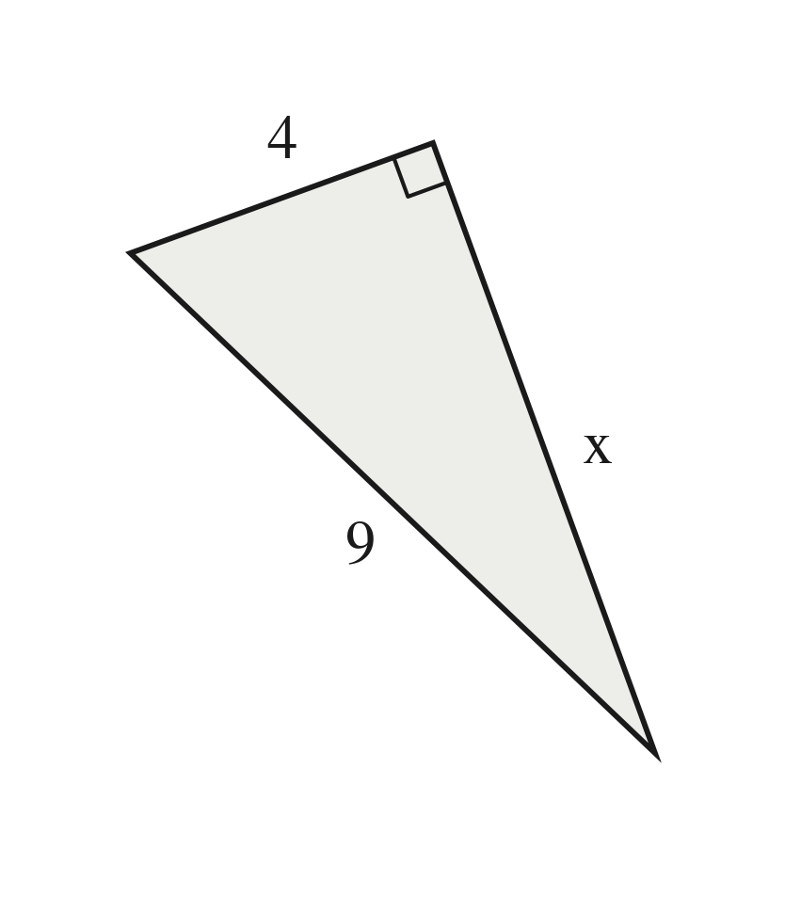
○ A. 4 + x = 9
○ B. 
○ C. 
● D. 
D
The 9 is across from the right angle, so it is c and stands alone: x² = 81 − 16 = 65.
Scoring: 1 point.

7. A rectangular garden measures 9 meters by 10 meters. A path runs straight across it from one corner to the opposite corner.
a. How long is the path, in meters? Round your answer to the nearest tenth. 1 pt
13.5 m (exactly √181 m)
the path is the hypotenuse: 81 + 100 = 181
b. How much shorter is the path than walking along two sides of the garden? Round your answer to the nearest tenth. 1 pt
5.5 m
9 + 10 = 19 m along two sides; 19 − 13.5. Follow-through on part (a).
Scoring: a 1 · b 1 = 2 points.

Part 3. Distance on the Coordinate Plane 6 points MA.8.GR.1.2
If an earlier part is wrong, a later part still earns its point when the right operation is applied to your own earlier answer — but only if that work is on the page.
8. Find the distance between points A and B. 1 pt
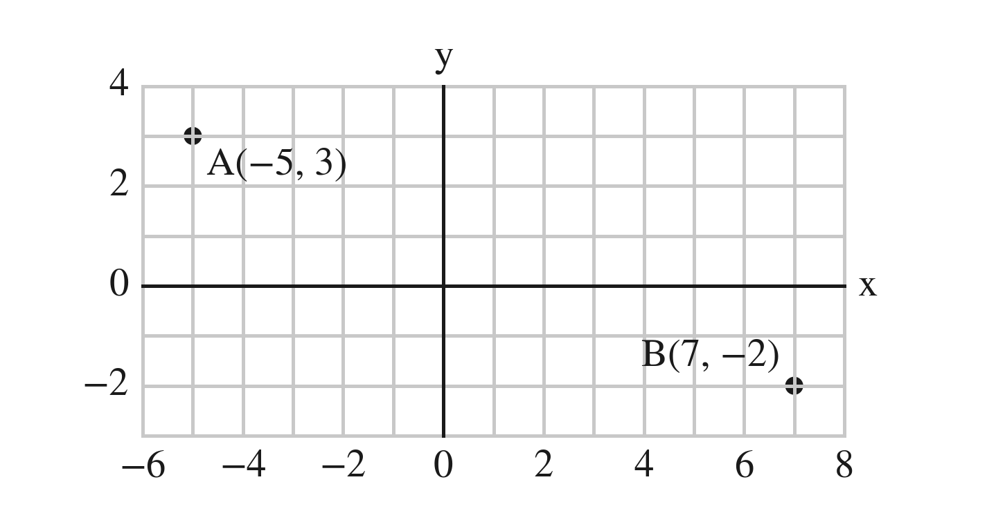
13 units
Across 7 − (−5) = 12, down 3 − (−2) = 5: c² = 144 + 25 = 169.
Scoring: 1 point.

9. Find the distance between (−1, 3) and (4, 1). Round your answer to the nearest tenth. 1 pt
5.4 units (exactly √29)
Across 5, down 2: c² = 25 + 4 = 29.
Scoring: 1 point.

10. Triangle JKL has corners J(−6, 1), K(8, 1) and L(8, 6).
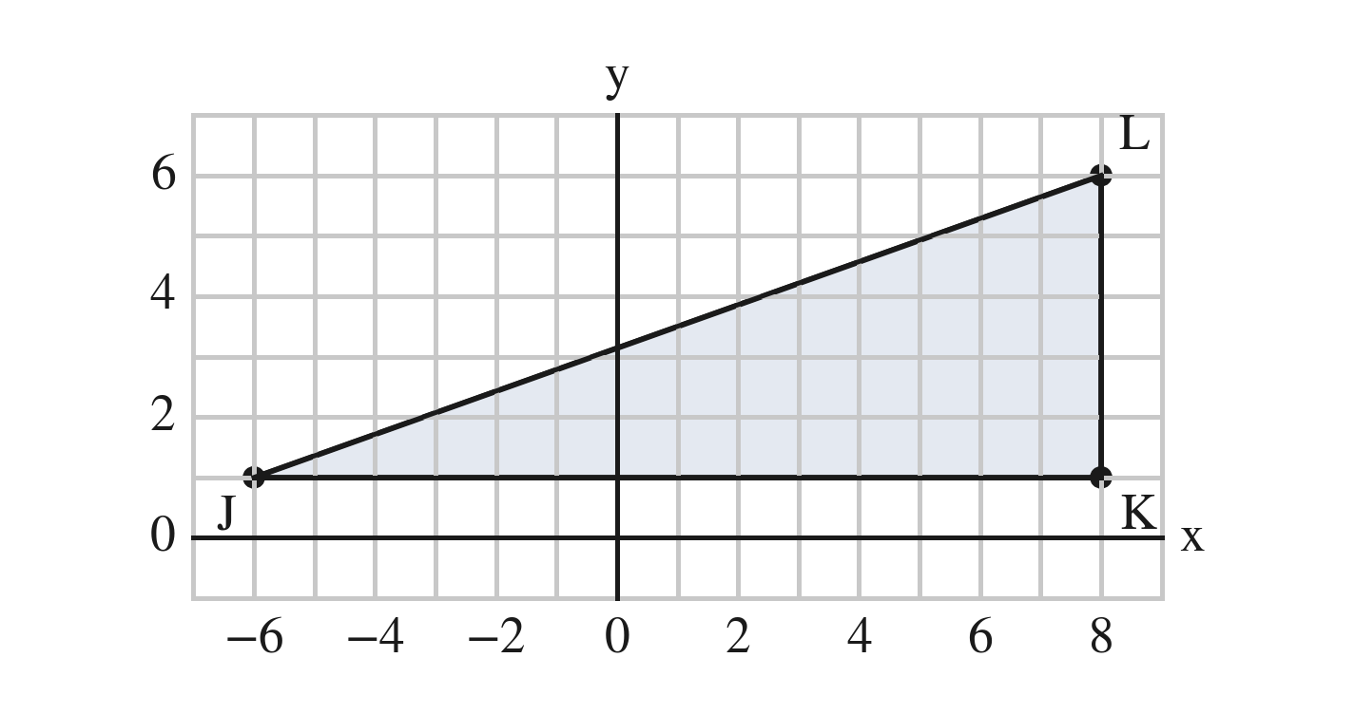
a. Find the length of side JK. 1 pt
14 units
Across zero: 6 + 8 — never 8 − 6.
b. Find the perimeter of triangle JKL. Round your answer to the nearest tenth. 1 pt
33.9 units
KL = 5; JL = √(196 + 25) = √221 ≈ 14.866; 14 + 5 + 14.866 = 33.866 — round once, at the end. Follow-through on part (a).
Scoring: a 1 · b 1 = 2 points.

11. On a town map, each unit is one block. The library is at (−1, −5) and the pool is at (8, 7).
a. How far is it from the library to the pool along the streets? 1 pt
21 blocks
The streets follow the grid: 9 across and 12 up.
b. How far is it in a straight line? 1 pt
15 blocks
The hypotenuse of legs 9 and 12: 81 + 144 = 225.
Scoring: a 1 · b 1 = 2 points.

Part 4. Similar Triangles 3 points MA.8.GR.2.4
12. The two triangles are similar. Find x. 1 pt
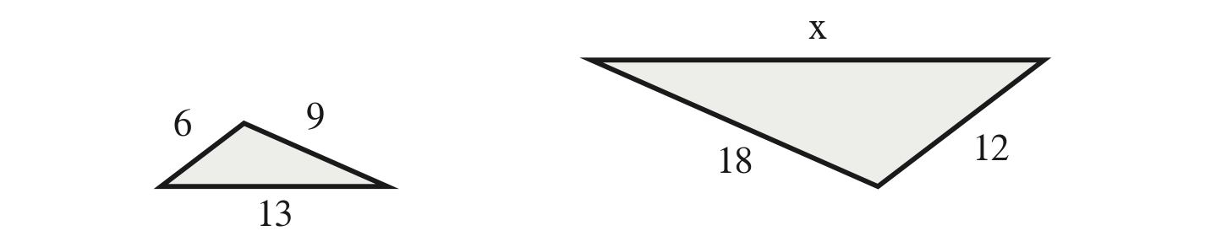
x = 26
Match by size: 12 with 6 and 18 with 9, so k = 2 and x = 13 × 2. 39 matched by place on the page (18 with the 6); 13 took similar as equal; 19 added the difference 12 − 6.
Scoring: 1 point.

13. A boy 4 ft tall casts a shadow 5 ft long. At the same moment, a tree casts a shadow 30 ft long. How tall is the tree? 1 pt
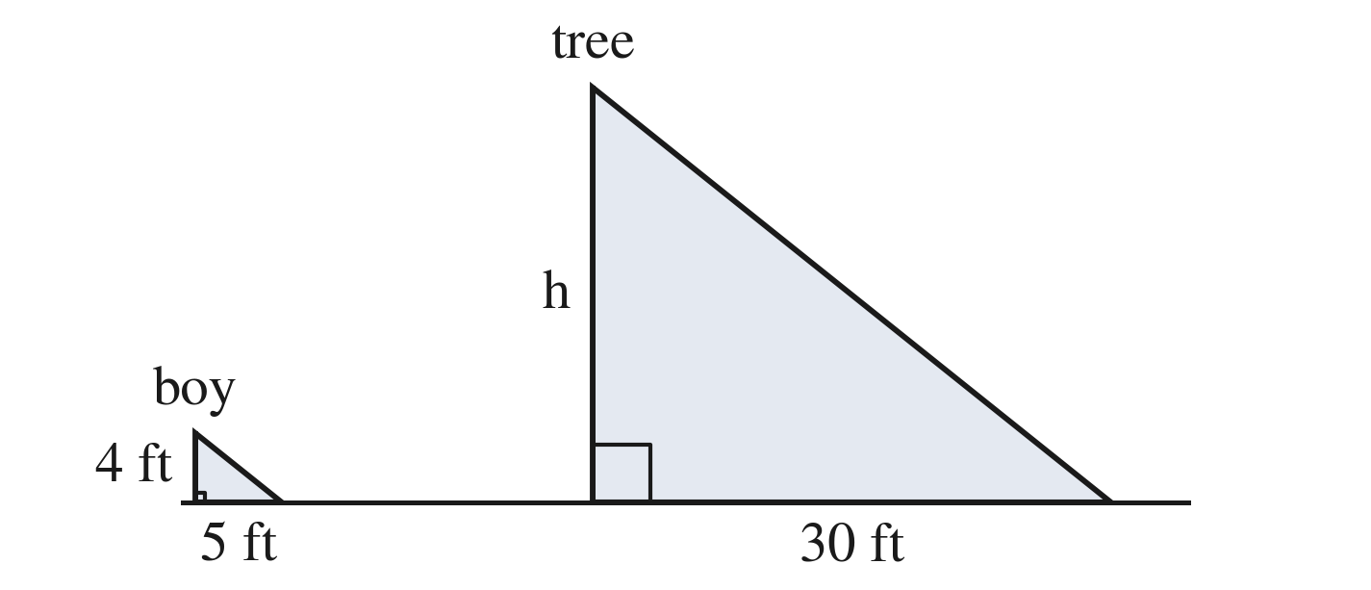
24 ft
k = 30 ÷ 5 = 6 from the shadows; 4 × 6. 37.5 matched height and shadow crosswise; 120 multiplied by the boy's height, not by k.
Scoring: 1 point.

14. Which triangle is similar to a triangle with sides 6, 7 and 10? 1 pt
● A. 12, 14, 20
○ B. 10, 11, 14
○ C. 12, 14, 18
○ D. 6, 7, 12
A
Every side × 2: 12/6 = 14/7 = 20/10.
Scoring: 1 point.

Score Tracker
Benchmark | Questions | Possible | Earned
MA.8.GR.1.3 | 1, 2, 3 | 3
MA.8.GR.1.1 | 4, 5, 6, 7 | 6
MA.8.GR.1.2 | 8, 9, 10, 11 | 6
MA.8.GR.2.4 | 12, 13, 14 | 3
Total |  | 18

If an earlier part is wrong, a later part still earns its point when the right operation is applied to your own earlier answer — but only if that work is on the page. Nothing is weighed and nothing is arguable: apply the part's operation to the student's own earlier value and tick if that is what is written.

